To begin, visit Microsoft's page for SQL Server. Find the section related to the Developer edition and click Download now:
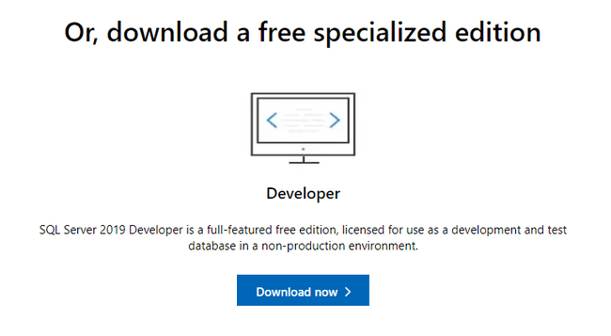
Once the download completes, double click on the file to run the installer (you may have to confirm that you wish to allow the program to make changes to your computer).
On the initial screen of the installer, you will be asked to choose what type of installation you want to perform:
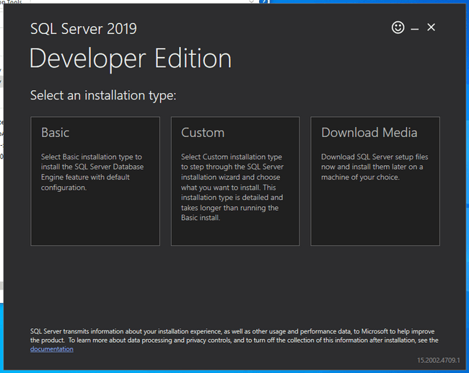
Choose Basic to continue on with a conventional installation using the most common options.
Next, you'll be asked to agree to the Developer Edition licensing terms:
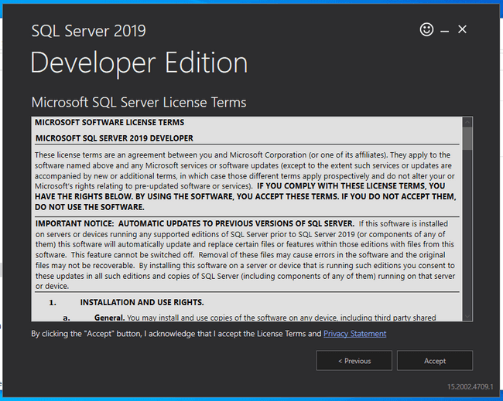
When you have read the license and agree to the terms, click Accept to continue.
Next, confirm or change the installation location:
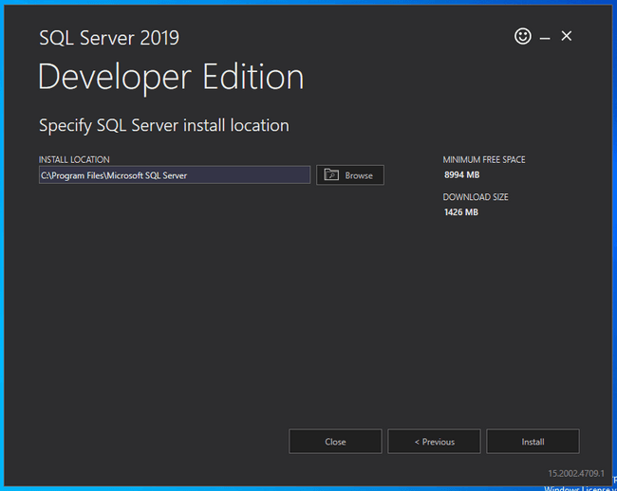
When you are ready, click Install to begin the installation process.
The installer will begin to download and install components to set up SQL Server on your computer:
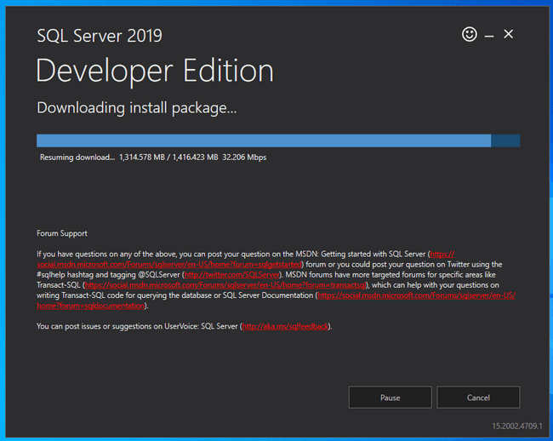
When the installation is finished, a screen will appear noting the current installation properties:
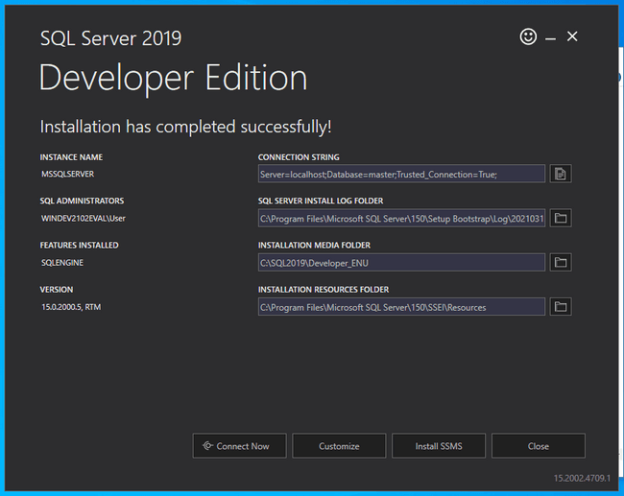
To connect to the new SQL Server instance right away, click Connect Now at the bottom.
A new window will Cmd window will appear and automatically log you into the SQL Server instance using the sqlcmd client:
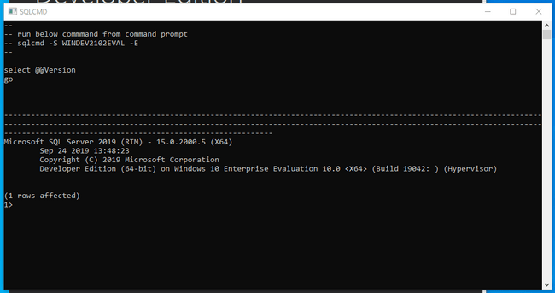
As shown in a comment at the top of the window, you can connect to SQL Server manually at any time with the sqlcmd client by typing:
sqlcmd -S <yourhostname> -E
To exit the current SQL session, type:
EXIT
RELATED ON PRISMA.IO
If you are using Prisma Client with SQL Server, you can use the SQL Server connector to connect, map your models, and manage your data.
You can also check out our guides to see how to use Prisma with Microsoft SQL Server on a new project or in an existing project.
Prisma is an open-source database toolkit for Typescript and Node.js that aims to make app developers more productive and confident when working with databases.

Setting up SQL Server on macOS
While Microsoft does not provide a native installer for macOS, they do support running SQL Server on macOS through Docker. The main SQL Server Docker container is built using a Linux container, allowing any host capable of running Docker containers to run the database server.
You'll need at least 2 GB of memory (probably at least a little more) to successfully run the image, however Docker itself requires at least 4 GB of memory.
To begin, make sure you have the Docker on your system. Docker Desktop for Mac includes Docker Engine and other related applications. If you don't already have Docker installed, follow the instructions included in the above link.
Once you have Docker up and running, you can pull the SQL Server Docker image from Microsoft Container Registry by typing:
docker pull mcr.microsoft.com/mssql/server:2019-latest
This will download all of the required image layers to your local system, allowing a faster startup.
When you're ready to start the container, type the following command.
Remember to replace <password> with the value of your intended password and choose a value that conforms to the image's password policy. At the time of this writing, the policy is defined as: "The password must be at least 8 characters long and contain characters from three of the following four sets: Uppercase letters, Lowercase letters, Base 10 digits, and Symbols.":
docker run --env "ACCEPT_EULA=Y" --env "SA_PASSWORD=<password>" --publish 1433:1433 --name mssql --hostname mssql --detach mcr.microsoft.com/mssql/server:2019-latest
The SQL Server container will be started up in the background. The string of characters displayed is the new container's ID.
You can verify that the container is up and running by typing:
docker ps -a
CONTAINER ID IMAGE COMMAND CREATED STATUS PORTS NAMES
ffa9ef357b5c mcr.microsoft.com/mssql/server:2019-latest "/opt/mssql/bin/perm…" 2 minutes ago Up 2 minutes 0.0.0.0:1433->1433/tcp mssql
ae00765e36fb hello-world "/hello" 24 minutes ago Exited (0) 24 minutes ago dreamy_swanson
You should see the mssql container among the list. If the container is not running or you have trouble, you can try viewing its logs to see if there are any helpful messages:
docker logs mssql
The SQL Server container not only has the database server installed, it also has some of the common tooling available, including the sqlcmd command line client. To use this client to connect to the database instance, you can use docker exec to access the command and authenticate against the database:
docker exec --interactive --tty mssql /opt/mssql-tools/bin/sqlcmd -U SA -S 127.0.0.1 -P "<password>"
You will be authenticated to the SQL Server inside the container and dropped into a SQL shell. You can verify that everything is up and running by typing:
SELECT @@VERSION;
GO
------------------------------------------------------------------------------------------------------------------------------------------------------------------------------------------------------------------------------------------------------------------------------------------------------------
Microsoft SQL Server 2019 (RTM-CU9) (KB5000642) - 15.0.4102.2 (X64)
Jan 25 2021 20:16:12
Copyright (C) 2019 Microsoft Corporation
Developer Edition (64-bit) on Linux (Ubuntu 18.04.5 LTS) <X64>

(1 rows affected)
To exit the SQL session and get back to your normal shell, type:
EXIT
To shut down the SQL Server container when you're done, you can stop it by typing:
docker stop mssql
To remove the container instance (including all data inside!), type:
docker rm mssql
To persist the data in your SQL Server container, you can use one of the techniques described in the Microsoft documentation or take a look at Docker's own documentation on using data volumes with containers.
RELATED ON PRISMA.IO
If you are using Prisma Client with SQL Server, you can use the SQL Server connector to connect, map your models, and manage your data.
You can also check out our guides to see how to use Prisma with Microsoft SQL Server on a new project or in an existing project.
Prisma is an open-source database toolkit for Typescript and Node.js that aims to make app developers more productive and confident when working with databases.

Setting up SQL Server on Linux
Installation methods differ depending on the Linux distribution you are using. Follow the section below that matches your Linux distribution. There are also instructions using Docker if you prefer that configuration or want to use a distribution not listed.
- Ubuntu
- CentOS and Red Hat
- With Docker

Ubuntu
The easiest way to install SQL Server on Ubuntu 20.04 is to install from the dedicated repositories provided by Microsoft. Your machine must have at least 2 GB of memory to successfully install and run the necessary software.
To begin, add a new repository definition to your system by typing:
sudo add-apt-repository "$(wget --quiet -O - https://packages.microsoft.com/config/ubuntu/18.04/mssql-server-2019.list)"
You also need to add a separate repository to get access to the sqlcmd binary and other tools:
sudo add-apt-repository "$(wget --quiet -O - https://packages.microsoft.com/config/ubuntu/20.04/prod.list)"
Next, add the Microsoft package signing key to apt so that it trusts the packages in the new repository:
wget --quiet -O - https://packages.microsoft.com/keys/microsoft.asc | sudo apt-key add -
With the repository set up, you can install SQL Server and the sqlcmd command line client by typing:
sudo apt install mssql-server mssql-tools unixodbc-dev
Once the installation is complete, you need to configure your new database instance. To do so, run the included mssql-conf setup script to set some of the basic properties of your new system:
sudo /opt/mssql/bin/mssql-conf setup
You will be asked a series of questions in order to configure the database server.
First, it will ask you what edition of SQL server you want to use:
Choose an edition of SQL Server:
1) Evaluation (free, no production use rights, 180-day limit)
2) Developer (free, no production use rights)
3) Express (free)
4) Web (PAID)
5) Standard (PAID)
6) Enterprise (PAID) - CPU Core utilization restricted to 20 physical/40 hyperthreaded
7) Enterprise Core (PAID) - CPU Core utilization up to Operating System Maximum
8) I bought a license through a retail sales channel and have a product key to enter.

Details about editions can be found at
https://go.microsoft.com/fwlink/?LinkId=2109348&clcid=0x409

Use of PAID editions of this software requires separate licensing through a
Microsoft Volume Licensing program.
By choosing a PAID edition, you are verifying that you have the appropriate
number of licenses in place to install and run this software.

Enter your edition(1-8):
If you have a paid license, you can choose the appropriate version. If you are using the server in a non-production environment, it is safe to choose the developer edition.
Next, you'll have to accept the license terms again:
The license terms for this product can be found in
/usr/share/doc/mssql-server or downloaded from:
https://go.microsoft.com/fwlink/?LinkId=2104294&clcid=0x409

The privacy statement can be viewed at:
https://go.microsoft.com/fwlink/?LinkId=853010&clcid=0x409

Do you accept the license terms? [Yes/No]:
Finally, you'll have to set and confirm a password for the SQL Server system administrator account (called the SA account in many places):
Enter the SQL Server system administrator password:
Confirm the SQL Server system administrator password:
To use the sqlcmd client to connect to your SQL Server instance, it's easiest to add the mssql-tools binary directory to your PATH. To configure this, type:
echo 'export PATH="$PATH:/opt/mssql-tools/bin"' >> ~/.bashrc
echo 'export PATH="$PATH:/opt/mssql-tools/bin"' >> ~/.bash_profile
Afterwards, re-source one of the two files above to evaluate the new PATH for your current session:
source ~/.bashrc
You can now connect to your database instance by typing:
sqlcmd -U SA -S 127.0.0.1
You'll be prompted for the password you set up earlier. After successfully authenticating, you will be dropped into an SQL shell. From here, you can verify that everything is working by printing the server's version:
SELECT @@VERSION
GO
------------------------------------------------------------------------------------------------------------------------------------------------------------------------------------------------------------------------------------------------------------------------------------------------------------
Microsoft SQL Server 2019 (RTM-CU9) (KB5000642) - 15.0.4102.2 (X64)
Jan 25 2021 20:16:12
Copyright (C) 2019 Microsoft Corporation
Developer Edition (64-bit) on Linux (Ubuntu 20.04.2 LTS) <X64>

(1 rows affected)
To exit the SQL shell and get back to the command line, you can type:
EXIT
RELATED ON PRISMA.IO
If you are using Prisma Client with SQL Server, you can use the SQL Server connector to connect, map your models, and manage your data.
You can also check out our guides to see how to use Prisma with Microsoft SQL Server on a new project or in an existing project.
Prisma is an open-source database toolkit for Typescript and Node.js that aims to make app developers more productive and confident when working with databases.

CentOS and Red Hat
The easiest way to get SQL Server installed on CentOS or Red Hat is to use the repositories provided by Microsoft. Linux hosts must have at least 2 GB of memory to install and run SQL Server.
Before installing SQL Server, you need to install and configure its dependencies. We need both Python 2 and OpenSSL 10 to continue:
sudo yum install python2 compat-openssl10
After Python 2 is installed, configure the system to use it as the default Python instance:
sudo alternatives --config python
From the list that follows, select the number associated with the Python 2 installation. In the example below, this will be option 2:
There are 2 programs which provide 'python'.

Selection Command
-----------------------------------------------
*+ 1 /usr/libexec/no-python
2 /usr/bin/python2

Enter to keep the current selection[+], or type selection number: 2
With the dependencies in place, you can now configure the SQL Server YUM repository:
sudo curl -o /etc/yum.repos.d/mssql-server.repo https://packages.microsoft.com/config/rhel/$(rpm --eval %{rhel})/mssql-server-2019.repo
Afterwards, you need to configure an additional repository to get access to the sqlcmd and other tools:
sudo curl -o /etc/yum.repos.d/msprod.repo https://packages.microsoft.com/config/rhel/$(rpm --eval %{rhel})/prod.repo
Once the repositories are configured, install SQL Server by typing:
sudo yum install mssql-server mssql-tools unixODBC-devel
Once the installation is complete, you need to configure your new database instance. To do so, run the included mssql-conf setup script to set some of the basic properties of your new system:
sudo /opt/mssql/bin/mssql-conf setup
You will be asked a series of questions in order to configure the database server.
First, it will ask you what edition of SQL server you want to use:
Choose an edition of SQL Server:
1) Evaluation (free, no production use rights, 180-day limit)
2) Developer (free, no production use rights)
3) Express (free)
4) Web (PAID)
5) Standard (PAID)
6) Enterprise (PAID) - CPU Core utilization restricted to 20 physical/40 hyperthreaded
7) Enterprise Core (PAID) - CPU Core utilization up to Operating System Maximum
8) I bought a license through a retail sales channel and have a product key to enter.

Details about editions can be found at
https://go.microsoft.com/fwlink/?LinkId=2109348&clcid=0x409

Use of PAID editions of this software requires separate licensing through a
Microsoft Volume Licensing program.
By choosing a PAID edition, you are verifying that you have the appropriate
number of licenses in place to install and run this software.

Enter your edition(1-8):
If you have a paid license, you can choose the appropriate version. If you are using the server in a non-production environment, it is safe to choose the developer edition.
Next, you'll have to accept the license terms again:
The license terms for this product can be found in
/usr/share/doc/mssql-server or downloaded from:
https://go.microsoft.com/fwlink/?LinkId=2104294&clcid=0x409

The privacy statement can be viewed at:
https://go.microsoft.com/fwlink/?LinkId=853010&clcid=0x409

Do you accept the license terms? [Yes/No]:
Finally, you'll have to set and confirm a password for the SQL Server system administrator account (called the SA account in many places):
Enter the SQL Server system administrator password:
Confirm the SQL Server system administrator password:
To use the sqlcmd client to connect to your SQL Server instance, it's easiest to add the mssql-tools binary directory to your PATH. To configure this, type:
echo 'export PATH="$PATH:/opt/mssql-tools/bin"' >> ~/.bashrc
echo 'export PATH="$PATH:/opt/mssql-tools/bin"' >> ~/.bash_profile
Afterwards, re-source one of the two files above to evaluate the new PATH for your current session:
source ~/.bashrc
You can now connect to your database instance by typing:
sqlcmd -U SA -S 127.0.0.1
You'll be prompted for the password you set up earlier. After successfully authenticating, you will be dropped into an SQL shell. From here, you can verify that everything is working by printing the server's version:
SELECT @@VERSION
GO
------------------------------------------------------------------------------------------------------------------------------------------------------------------------------------------------------------------------------------------------------------------------------------------------------------
Microsoft SQL Server 2019 (RTM-CU9) (KB5000642) - 15.0.4102.2 (X64)
Jan 25 2021 20:16:12
Copyright (C) 2019 Microsoft Corporation
Developer Edition (64-bit) on Linux (CentOS Linux 8) <X64>

(1 rows affected)
To exit the SQL shell and get back to the command line, you can type:
EXIT

